**Department of Computer Science and Engineering**

|  |  |
| --- | --- |
| **Course Code:CSE422** | **Credits: 1.5** |
| **Course Name: Artificial Intelligence** | **Prerequisite:** CSE111, CSE221 |

**Lab 01  
Basics of python for Artificial Intelligence**

1. **Lab Overview:**

Learn Basic Python programming concepts such as: Data types, array, data dictionaries, method, functions, Loops, condition, installing libraries and importing class, package installation, getting familiar with python IDE, and basic commands

1. **Why Python for AI course:**

AI (artificial intelligence) opens up a world of possibilities. By taking advantage of machine learning or deep learning, you could produce many fascinating applications. But, which programming language should you use? You want a language having wide range of well documented libraries and a large community of programmers. Hence, whatever you want to do can be found in web as a reference. Python has all these advantages.

1. **Lesson Fit:**

There is pre-requisite to this lab: CSE111, CSE221. You should have intensive Programming Knowledge and capability of understand algorithms.

1. **Acceptance and Evaluation**

Performed lab tasks will be evaluated by the Lab Instructor (LI)

* 1. Short viva will be conducted in each Lab or occasionally to examine your work.
  2. You may work in groups but be aware that you will be evaluated individually; hence active participation during the Lab work demonstration is recommended.
  3. There will be Lab handout after your work you have to handover it to LI

1. **Learning Outcome:**

After this Lab, the students will be able to:

* 1. Understand basic python codes and solve basic programming problems in python

1. **Activity Detail**
   1. **Hour: 1  
      Getting Started:**
      1. Have a glance at Books “Python code for Artificial Intelligence: Foundations of Computational Agents,” by David L. Poole and Alan K. Mackworth, May 28, 2018
      2. “Artificial Intelligence with Python written by Prateek Joshi, January 2017
      3. Check \\TSR to see e-book copy and codes, tutorials and useful links

**Running IDE and Code**

If your operating system is Windows then

* + - 1. Run “anaconda navigator software 🡪 spyder IDE” from the root Icon which is shown in desktop.
      2. Your Lab PC should have anaconda software installed if not then inform Lab instructor immediately

If your operating system is Unix based then

1. You have to set environment variable from Terminal, hence run Unix Terminal and execute the following command

export PATH="/opt/anaconda/anaconda3/bin:$PATH"

1. Then run command anaconda-navigator in the terminal, if terminal takes sometime that means it will appear within a moment
2. From anaconda navigator software run spyder IDE. You can also use Jupyter Notebook IDE which is also very popular among communities.
3. If your command anaconda-navigator shows command not found then either anaconda is not installed or installed in different location
4. “export PATH” This command means you are declaring that anaconda executable file is in /opt/anaconda/anaconda3/bin in this folder, Hence, it’s better to check whether anaconda is actually installed in /opt, using command “ls -ltr /opt/anaconda”
5. if anaconda is not present then inform Lab instructor instantly

**Installing Library**

To install library use the following command in Terminal/windows command prompt “pip install libraryname”

**Get to know about IDE**

1. 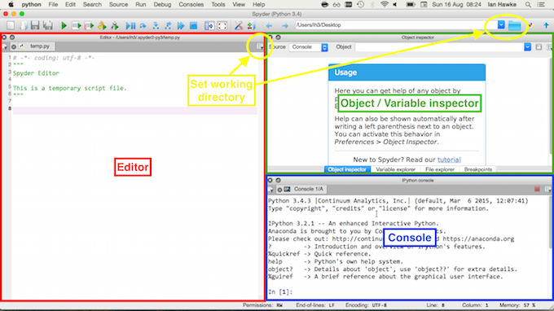See the attached screen shot to learn about the IDE, in the console you can write code like a Unix terminal
2. In the Editor block we can write code and execute whole program using the green arrow sign at the top, variable explorer exhibits the variables
3. If Open folder option is clicked from the menu-bar then whatever the folder location is opened in the editor actually determines the root folder for IDE. If any file is called within a script in the IDE you don’t need to specify file location if the file is kept in the root folder

**Get to know about basic python:**

1. Python List and tuple, function calling, if else scope, loops and many more

<https://www.programiz.com/python-programming/list>

**Assigning value to a Variable in Python**

You can use the assignment operator = to assign the value to a variable.

website = "Apple.com"

print(website)

a, b, c = 5, 3.2, "Hello"

print ("A:",a,"B:",b,"C:",c)

**Import a file variables**

#Create a file constant.py

PI = 3.14

#Create a main.py

import constant

print(constant.PI)

When you run the program, the output will be: 3.14

**Collections of variables**

Four different collections List literals, Tuple literals, Dict literals, and Set literals.

fruits = ["apple", "mango", "orange"] #list

numbers = (1, 2, 3) #tuple

alphabets = {'a':'apple', 'b':'ball', 'c':'cat'} #dictionary

vowels = {'a', 'e', 'i' , 'o', 'u'} #set

print(fruits,numbers,alphabets,vowels)

**Declaring function and passing arguments values**

drink = "Available"

food = None

def menu(x): # it’s a declared function

if x == drink:

print(drink)

else:

print(food)

menu(drink) # This is how you can call function and pass parameter values

menu(food) # This is how you can call function and pass parameter values

**IF ElSE statements**

num = 3.4

if num > 0:

print("Positive number")

elif num == 0:

print("Zero")

else:

print("Negative number")

**For loop without else statement**

numbers = [6, 5, 3, 8, 4, 2, 5, 4, 11]

sum = 0

# iterate over the list

for val in numbers:

sum = sum+val

print("The sum is", sum)

# Program to iterate through a list using indexing

genre = ['pop', 'rock', 'jazz']

# iterate over the list using index

for i in range(len(genre)):

print("I like", genre[i])

**For loop with else statement**

digits = [0, 1, 5]

for i in digits:

print(i)

else:

print("No items left.")

**While loop with else statement**

counter = 0

while counter < 3:

print("Inside loop")

counter = counter + 1

else:

print("Inside else")

**Activity List**

**Task 01:** Mark 10 **Time:** 1 hour

**Solve the following problems with python programming language**

#1.Write a program that convert percentage to decimal.

#Example: Enter percentage: 125%

#Equivalent decimal: 1.25

#2. Question 3. Write a program to convert temperature from Centigrade (C’) to Fahrenheit (F’)

#Far=1.8Cel+32

#3.Write a program that asks the user to enter a whole number of inches and convert that length to feet and inches. See the following figure. The program should use both integer division and the modulus operator.

#Examples: Enter number of Inches: 185

#185 inches if 15 feet and 5 inches

#4. A copy center charges 50 won per copy for the first 100 copies and 30 won per copy for each additional copy.

#Write a program that requests the number as input and displays the total cost.

#5. A calendar year divisible by four is a leap year, with the exception of the years ending in 00 (that is, those divisible by 100) and not divisible by 400. For instance the years 1600 and 2000 are leap years, but 1700, 1800, and 1900 are not.

#Write a program that requests a year as input and states whether it is a leap year.

#parameters = "/?access_token=%s" % (access_token)

#6. Print average of all numbers divisible by 3 and less than 100.

#7. A person born in 1980 can claim, "I will be x years old in the year x squared." '. What is the value of x?

#Hints: It forms a quadratic equation X^2-X-1980=0

#8. A list has 6 numbers. Print sum of the smallest and largest number,

#sum of second smallest and second largest, and sum of third smallest and third largest number.

#9. Make a list with 10 numbers and print: (a) the difference between average number and smallest number, and

#(b) difference between average and largest number.

#10. Write a python program to find area of a triangle. Inputs are the 3 sides of triangle.